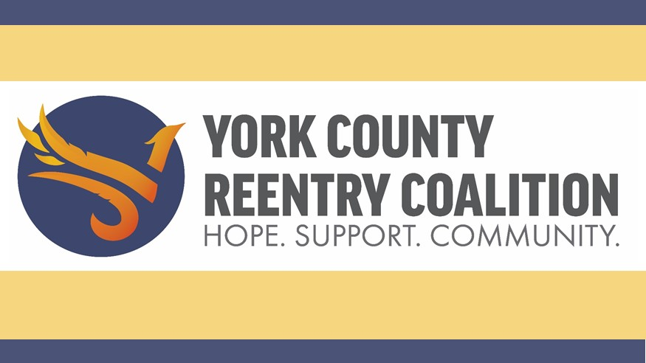

Strategic Plan
FY 2024 – 2026
November 14, 2023

Table of Contents

Introduction………………………………………………………………………………………………...……... 3

Overview of the Planning Process…………………………………………..…………..……….……… 3

Mission Statement…………………………………………………………………………….……………..…. 4

Vision Statement………………………………...…………………………………………….…….………..… 4

Values Statement…………………………………………………………………………………..……….…… 4

Strategic Imperatives, Goals, and Objectives…………………………..………………….……….. 5

Introduction
The York Country Reentry Coalition (YCRC) was created in September 2016 to connect those leaving prison and reentering society in York County with available resources. The main goal of the YCRC is to help these men and women during a time of transition in their lives by providing education, ac0cess to resources such as housing, and guidance on how to move forward after prison.
The YCRC is made up of more than 100 individuals, agencies and organizations devoted to providing reentry programs and support to those returning to society. The members of these agencies are part of the YCRC because they want to help, and they care about providing assistance to individuals transitioning from prison back to society. This large network of resources is made up of government agencies, local businesses, faith-based entities and service providers. By combining the resources of these organizations, the YCRC provides reentry assistance services including interviews, education, various treatment options, and ongoing skills development. Support and guidance are also offered to family members who have questions or need direction as their loved ones leave prison.

When using the resources provided by the YCRC, those ending their prison sentence can expect to build relationships while getting the specific assistance they need to make sure they are on the right track to succeed after prison. The members are simply people helping people create safer and healthier communities, restore lives and families, and ensure access to resources for other community needs.

As the YCRC continues to grow and evolve, staff and board leadership wanted to recast the strategic plan for the next three year. CBY Professional Services was engaged to lead and facilitate the process. The result of this collaboration is the document below.

Overview of the Planning Process
The planning process began in January 2023 with two focus groups comprised of the Workforce Engagement Committee and the Consumer Advisory Board. Individual interviews were conducted with the following individuals.
Annie Camillo,  YC Prison | Sharon Collare,  YC Prison | Valerie Conway,  YC Prison
Michelle Crosson,  WellSpan | Mary Dolheimer,  Not One More | Kelly Evans,  PA State Corrections, Reentry
Karen Fitch,  Highmark Wholecare | Aliceanne Frost,  The Program, It’s About Change | Dr. Matt Howie,  WellSpan Health
Michael Leister,  PA Crime & Delinquency | Adam Ogle,  YC Prison | Da’Laine Simpson,  Bro to Go
Katie Wilt,
WellSpan Health
The Strategic Planning Committee held a half day retreat February 24, 2023 to discuss the following topics: Mission Statement, Vision Statement, Values Statement, and strategic topics that included Roles and Responsibilities, Community Awareness, and Reentrant Needs.

Following the retreat, the committee met to review and provide feedback on drafts of the plan in April, June, and July. The final meeting was conducted in November to approve the plan and the review the Implementation Plan.

Mission Statement
To empower individuals (reentrants and their support networks) to be successful by building connections, resources, and support to improve the quality of life, break the cycle of recidivism, and restore dignity.

Vision Statement
A safer, healthier, and stronger York County.

Values Statement
- Collaborative: we leverage the power of public private partnerships to optimize resources.

- Innovative: we seek out new ideas and approaches to solve the complex issues our individuals face every day.

- Supportive: we do all we can to ensure individuals have what they need to succeed.

- Trustworthy: we are a reliable resource for support and advocacy.

- Empathetic: in a dignified and unbiased way we meet the people we serve where they are.

- Educational: we continually advocate for individuals and resolving the challenges they face by ensuring everyone understands their perspective.

- Person-First: we are guided by lived experiences and doing what in best for the individuals we serve.

Strategic Imperatives, Goals & Objectives

Strategic Imperative #1: Increase Awareness and Number of Individuals Served

Goal #1: Develop and Implement a Strategic Awareness Campaign

Objective #1
Develop and implement an awareness campaign focused on increasing the number of individuals served by the YCRC.

Objective #2
Develop and implement an awareness campaign focused on reducing the stigma associated with reentry.

Goal #2: Operationalize the ROC

Objective #3
Work with community partners to increase the number of services offered and individuals served at the ROC.

Objective #4
Hold an official grand opening and ribbon cutting in Fall 2023.

Goal #3: Continue to Develop Strategic Partnerships Across the Community

Objective #5
Identify potential partners that specialize in state identification, secure at least one formal partnership by June 2024.

Objective #6
Identify potential partners that specialize in transportation, secure at least one formal partnership by the end of 2024.

Objective #7
Identify potential partners that specialize in medical care, secure at least one formal partnership by June 2024.

Objective #8
Identify potential partners that specialize in housing, secure at least one formal partnership by June 2024.

Objective #9
Identify potential partners that specialize in workforce development, secure at least one formal partnership by June 2024.

Strategic Imperative #2: Recruit and Retain the Best and the Brightest

Goal #4: Recruit and Retain the Best and Brightest Staff

Objective #10
Successfully onboard new staff to ensure alignment with organization goals.

Goal #5: Recruit and Retain the Best and Brightest Volunteers

Objective #11
Develop and implement a succession plan for the Board of Directors.

Objective #12
Develop and implement a succession plan for each committee.

Strategic Imperative #3: Provide Efficient & Effective Services

Goal #6: Create a Comprehensive Offering of Programs and Services

Objective #13
Develop and implement a supportive case management program.

Objective #14
Develop and implement an effective mentorship program.

Objective #15
Develop and implement a robust peer support program.

Goal #7: Work with Community Partners to Develop Solutions to Chronic Challenges

Objective #16
Identify community initiatives focused on housing, participate as appropriate and advocate for the needs of reentrants.

Objective #17
Identify community initiatives focused on transportation, participate as appropriate and advocate for the needs of reentrants.

Objective #18
Identify community initiatives focused on workforce development, participate as appropriate and advocate for the needs of reentrants.

Strategic Imperative #4: Build a Sustainable Business Model

Goal #8: Diversify and Optimize Revenue Streams

Objective #19
Identify, apply for, and secure at least three new mission aligned grants per year for three years.

Objective #20
Increase philanthropic support 10% per year for three years.

Goal #9: Implement a Functional Committee Structure

Objective #21
Annually review the committee structure to ensure the changing needs of the organization are met.

